DELVING INTO THE WORLD OF INTERNET COMMUNICATION WITH WINDOWS APIS

The Internet, a vast network of interconnected computers spanning the globe, has revolutionized personal computing, enabling seamless communication, information access, and resource sharing.



While dial-up information services and electronic mail systems existed previously, their character-based interfaces and isolated nature presented limitations. Each information service required a separate connection and login credentials, and email exchanges were restricted to users within the same system.



The era of isolated information services has given way to a unified Internet experience, brought about by the ubiquity of high-speed connectivity and the adoption of open communication protocols.



With a single Internet connection, individuals can now communicate with anyone worldwide, and the World Wide Web, with its hypertext structure, multimedia elements, and interactive features, has expanded the scope and accessibility of online information.



To harness the power of the Internet in Windows applications, developers can leverage various APIs (Application Programming Interfaces) that provide a structured approach to communication and data exchange. Two prominent APIs that stand out for their simplicity and effectiveness are Windows Sockets (WinSock) and Windows Internet (WinInet).

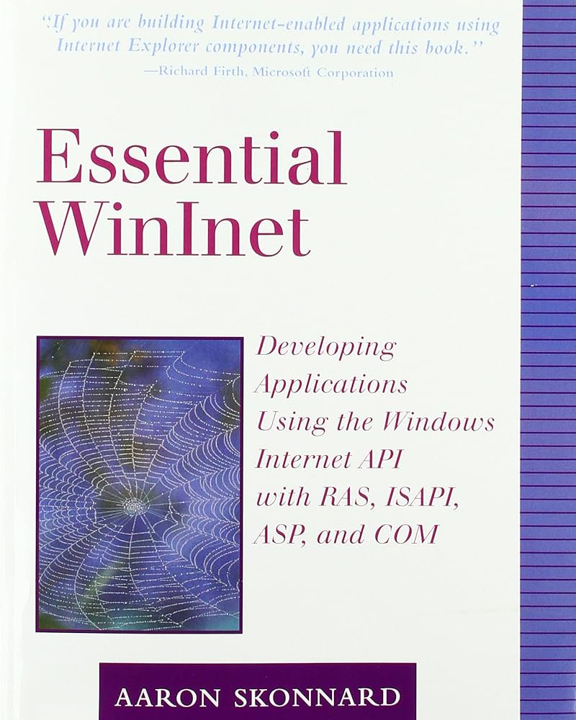 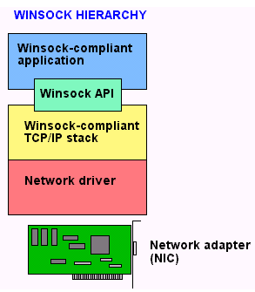

Winsock: The Foundation Of Internet Communication

WinSock, the Windows Sockets API, forms the cornerstone of Internet programming in Windows. It provides a standardized set of functions for creating network sockets, establishing connections, sending and receiving data, and managing network errors.

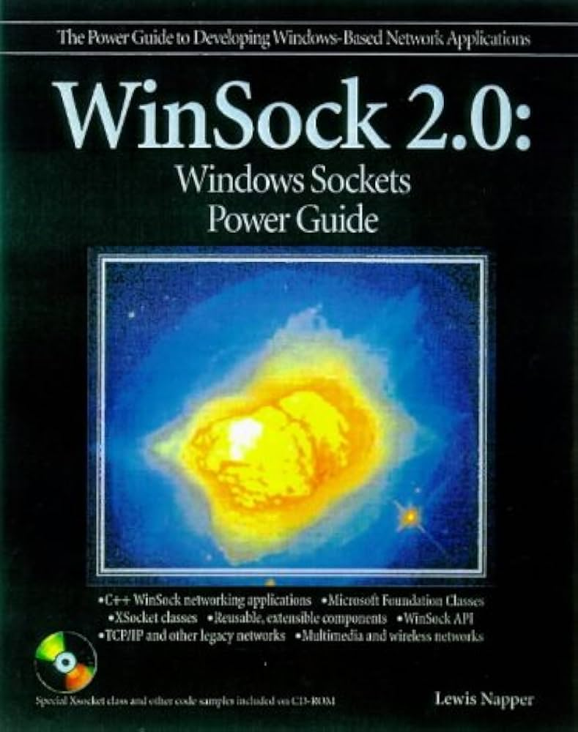

WinSock simplifies the process of interfacing with the underlying network protocols, enabling developers to focus on higher-level application logic rather than the intricacies of network-level communication.

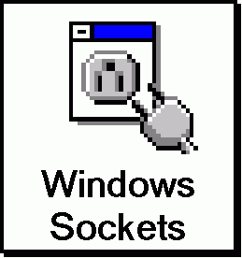 
        +-----+      +-----+      +-----+
        | App |      | App |      | App |     (Application Layer)
        +-----+      +-----+      +-----+
        ---------------------------------
              Winsock 2.0 API Layer           (Presentation Layer)
        ---------------------------------
                +-------------+
                | Winsock.DLL |              
                +-------------+
        ---------------------------------
              Winsock 2.0 SPI Layer           (Session Layer)
        ---------------------------------
            +--------+   +---------+ 
            | TCP/IP |   | IPX/SPX |          (Transport Layer)
            |  Stack |   |  Stack  |          (Network Layer)
            +--------+   +---------+ 
        ---------------------------------
             Network Device Drivers           (Data-Link Layer)
        ---------------------------------
CAPTION:  The Winsock 2.0 Hierarchy

Wininet: Simplified File Transfer And Web Access

WinInet, the Windows Internet API, extends the functionality of WinSock by providing a higher-level abstraction for common Internet tasks, such as file transfer through File Transfer Protocol (FTP) and web browsing through HTTP (HyperText Transfer Protocol).



WinInet simplifies the process of downloading and uploading files, navigating web pages, and interacting with web services, making it particularly suitable for web-based applications.

Selecting the Right API

The choice between WinSock and WinInet depends on the specific requirements of the application.

For complex network communication involving custom protocols or low-level data handling, WinSock offers greater control and flexibility.

WinInet is better suited for applications that primarily involve downloading and uploading files, accessing web pages, or performing general Internet-related tasks.



WINDOWS SOCKETS: A COMPREHENSIVE OVERVIEW

Windows Sockets (WinSock), an Application Programming Interface (API), provides a standardized and efficient method for network programming in Windows operating systems. It serves as a foundational layer for building applications that communicate over the Internet or local networks.

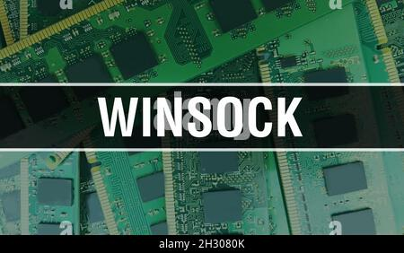

Socket Concept and TCP/IP Connection

The concept of sockets originated at the University of California, Berkeley, as a way to integrate network communication capabilities into the UNIX operating system. This API, known as the "Berkeley socket interface," has since become the de facto standard for network programming across various operating systems.



Sockets operate in conjunction with the Transmission Control Protocol/Internet Protocol (TCP/IP), the widely adopted set of protocols that govern Internet communications. TCP/IP comprises two primary layers:

Internet Protocol (IP): IP handles the addressing and routing of data packets across the network. It fragments data into smaller packets, assigns each packet with a destination address, and transmits them across the network.

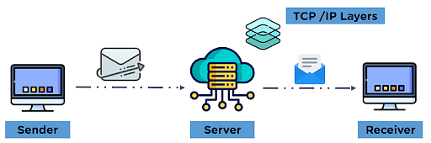

Transmission Control Protocol (TCP): TCP provides reliable data transfer between applications. It establishes a connection between two applications, ensuring that data is transmitted in an error-free and ordered manner.

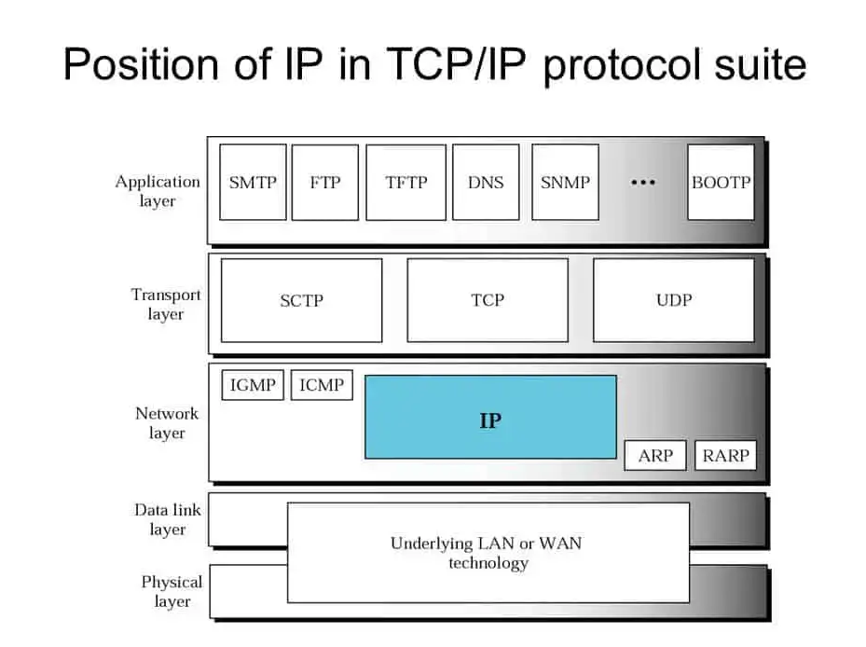

Socket Address and Communication Endpoints

In the context of TCP/IP communications, a socket represents a communication endpoint, identified by a unique combination of an IP address and a port number.

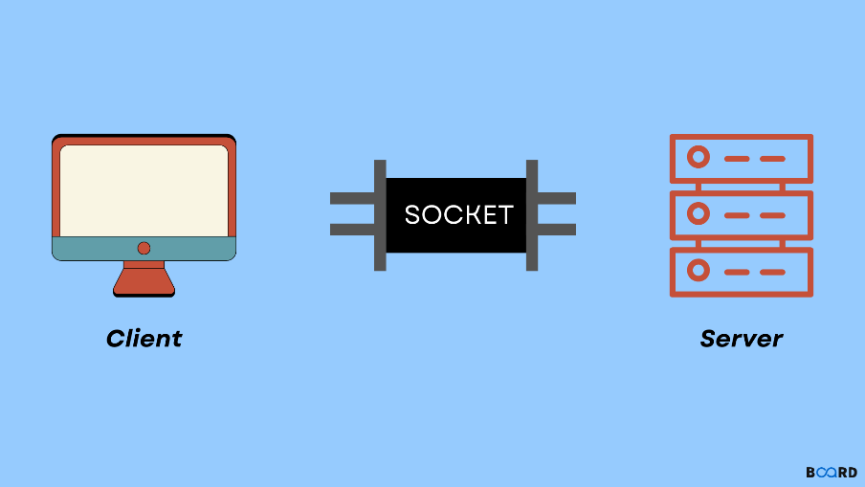

The IP address, typically represented in dotted-quad notation (e.g., 209.86.105.231), identifies the specific network device or server involved in the communication. The port number, a numerical identifier, further specifies the application or service running on that device or server.



TYPES OF SOCKETS AND CONNECTION ESTABLISHMENT

WinSock supports two primary types AND two secondary types of sockets:

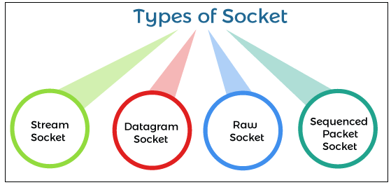

* Stream sockets: Provide a reliable, connection-oriented communication channel, similar to a telephone call. Data is transferred in a continuous stream, ensuring error-free delivery.
* Datagram sockets: Offer an unreliable, connectionless data transfer mode. Data is sent as discrete packets, each with its own destination address. Datagram sockets are often used for low-latency and high-throughput applications.
* Raw Sockets: Raw sockets provide direct access to lower-level communication protocols, allowing developers to manipulate network packets at the raw IP level. This enables advanced network programming tasks such as packet filtering, packet injection, and development of custom network protocols. Unlike stream and datagram sockets, which handle data transfer in predefined formats, raw sockets allow developers to directly construct and manipulate IP packets, including headers, options, and payload data. This level of control is essential for advanced networking tasks that require granular control over network traffic.
* Sequenced Packet Sockets: Also known as sequenced datagram sockets, offer a middle ground between stream and datagram sockets. They provide a connection-oriented data transfer mechanism, similar to stream sockets, but with the ability to maintain packet boundaries. This allows for more efficient data transfer with low latency and high throughput. They are often used in applications that require reliable data delivery while also maintaining packet integrity. They are particularly useful for streaming applications where the order of packets is crucial, such as video conferencing or real-time audio transmission.

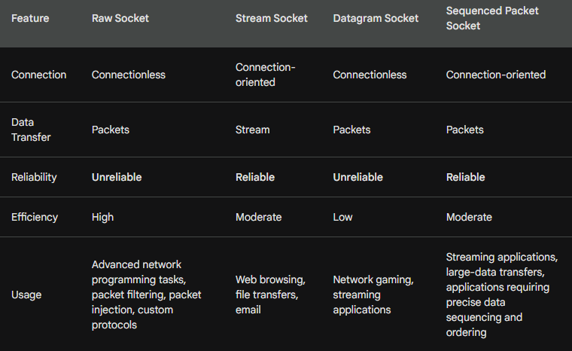

To establish a connection using WinSock, applications typically follow these steps:

* Create a socket: Allocate a socket object using the appropriate socket function, specifying the desired socket type and protocol.
* Bind the socket: Associate the socket with a specific IP address and port number, which determines the communication endpoint.
* Connect or listen: For stream sockets, applications can connect to a remote server using the connect function. For datagram sockets, servers listen for incoming connections by using the listen function.

WinSock Functions and Data Structures

WinSock provides a comprehensive set of functions for various network operations, including:

* Create and manage sockets: Functions for creating, binding, and closing sockets.
* Data transfer: Functions for sending and receiving data, both in stream and datagram mode.
* Address manipulation: Functions for working with IP addresses and port numbers.
* Error handling: Functions for detecting and handling network errors.

WinSock also defines various data structures, such as sockaddr structures for specifying socket addresses and WSADATA structure for storing WinSock version and API information.

Applications of WinSock

WinSock is widely used in various applications, including:

* Web browsers: To connect to web servers and retrieve web pages.
* Email clients: To send and receive emails from remote servers.
* File transfer protocols: To upload and download files from remote servers.
* Network games: To facilitate online multiplayer gaming experiences.
* Remote access tools: To establish remote connections to other computers for administration or support purposes.